

Smart Student Productivity Tracker

  - School of Computer Science and Maths
  - LJMU
  - Student: Arwa Daaboul
  - Supervisor: Dr Hoshang Kolivand

Abstract
200-300 words including
Introduction( importance of the work). First sentence
Problem statement. second sentence
Methodology: how you want to do the work, 2 to 3 sentences
Finding: what is the result at the end, one sentence.

Chapter 1:
Introduction (7-15) pages

1.1 Introduction

In the contemporary higher education landscape, students face unprecedented levels of pressure to excel academically while managing their personal well-being. This intense environment often leads to significant challenges, including [...finish the sentence by mentioning student stress, burnout, or mental health challenges]. The need for effective time management and productivity strategies has therefore never been more critical.
In response, a significant market of digital productivity tools and mobile applications has emerged, designed to help students manage their schedules and build effective habits. However, these tools are often generic, one-size-fits-all solutions. They frequently fail to address the realities of modern student life, particularly the extensive issue of [...finish the sentence by mentioning digital distraction, the impact of social media, or high screen time].
This highlights a critical gap for a new class of scheduler that is not just a static digital calendar, but an intelligent and adaptive productivity partner. The motivation for this project stems from the opportunity to apply modern machine learning techniques to create a system that understands and adapts to a student's unique daily condition, [...finish the sentence by stating your goal, e.g., 'ultimately fostering a healthier and more effective approach to studying.'].

1.2 Problem Statement

The main problem is a specific technical and practical issue in which current schedulers are not equipped to handle scheduling around a student's fluctuating ability to focus. These tools operate on the flawed assumption that all hours of the day are equal, ignoring the dynamic internal and external factors that [...]finish the sentence by mentioning how these factors impact a student's ability to concentrate or work effectively].
This challenge is confirmed by a recent study which reveals that students are in urgent need for solutions addressing their sleep hygiene, mental health, and digital behaviours to improve their academic performance (Sharma, 2025). However, despite this recognised need, a significant gap exists in the availability of practical, automated tools designed to provide this support. The current generation of productivity apps are not equipped to create the 'structured bedtime routines' or manage the digital distractions that research shows are required, which is the specific problem this project aims to address.

exhibit moderate to poor sleep quality, significant cognitive variability under stress conditions, and concerning mental health trends, with digital distractions emerging as a key barrier to healthy sleep. Moderate study habits, environmental sleep disruptions, and high screen time usage further compound these challenges, emphasizing the complex interplay between lifestyle factors and well-being. Implication:The findings underscore the urgent need for interferences targeting sleep hygiene, mental health support, and digital behavior management to enhance cognitive performance and emotional resilience among students. Promoting structured bedtime routines and providing education on reducing digital distractions may significantly improve students' academic outcomes and overall quality of life.
A student's ability to perform "deep work" is influenced by several measurable variables. This project will investigate the predictive power of key lifestyle factors, including the number of hours they have slept, their mental health rating, and the hours they spend on distractions such using social media and Netflix as recorded in the chosen dataset. For example, insufficient sleep has been shown to [...finish the sentence by explaining its effect on focus], while high stress levels can [...finish the sentence by explaining its effect on performance].
This mismatch between a student's assigned tasks and their actual cognitive state leads to inefficiency, frustration, and can contribute to academic burnout. Therefore, a significant problem exists there is no intelligent system that can automatically ingest these dynamic, user-specific variables to predict an individual's focus state and schedule tasks accordingly.

1.3 Aim
The aim of this project is to design, implement, and evaluate an intelligent scheduler that uses a machine learning model to predict a student's focus level and generate an optimised daily schedule.

1.4 Objectives

- To investigate existing literature on student productivity and distractions, personalised scheduling algorithms, and the application of machine learning for user behaviour prediction.
- To develop and train a predictive machine learning model by processing a public dataset to engineer a 'Focus_Level' target variable and using this data to predict a student's daily focus.
- To implement a functional prototype/web application that integrates the predictive model to generate an optimised daily schedule based on a user's tasks.
- To evaluate the results of the application by assessing the model’s technical performance and validating its practical utility with a custom-collected dataset.

1.5 Contribution
1.6 Scope
1.7 Structure of thesis

Chapter 2:
Literature (15-30 pages)
At least 30-40 citations in different categories is needed (Kolivand and Raja., 2020).
Jáuregui et al. (2005) presented a new ….

It is good to add some statistics on your search. Draw some tables and diagrams to see how you find the related papers.

Kolivand et al. (2020) proposed a new system to ….
Categorisation is important
Long Discussion or Conclusion is needed as can be seen in Figure 2.1.

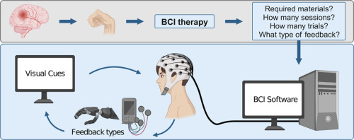
Figure 2.1 : BCI methdodology (Cantillo-Negrete et al.,2023)

Don’t forget to add a systematic searching for your data collection. I mean the methodology on how you find the papers.

Chapter 3: Methodology (10 pages) and Requirement Analysis
Requirements Analysis & Methodology

Research Framework:
How you want to achieve the objectives
Draw a diagram and explain each step
Example

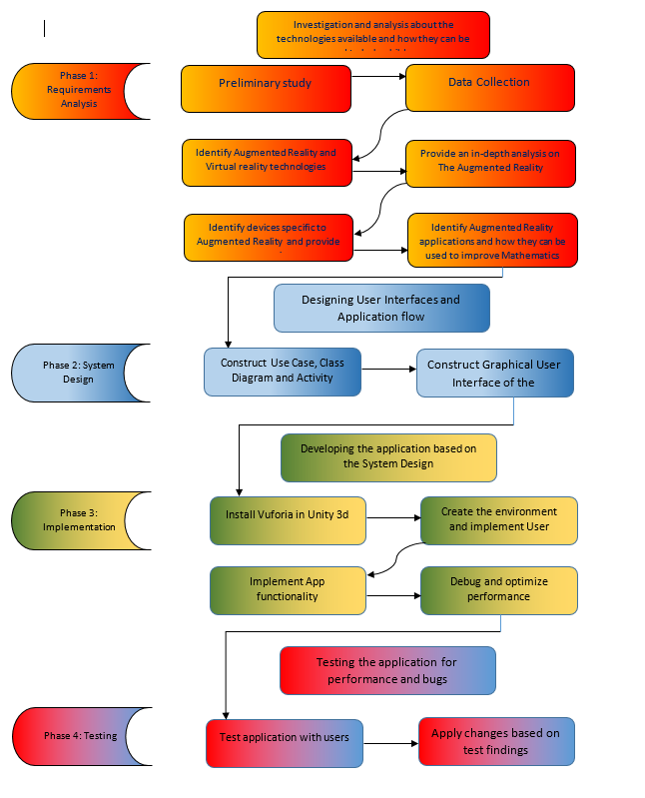
3.1 Research Framework
Explain all one by one
Add all software and tools you are going to us

Chapter 4: theory and Design
Which algorithms you have used and how and why….
Design the application as well
Visio

Chapter 5: Implementation(results and discussion)
Position part of the codes, why you did and how eaxplain…

Chapter 6: testing and Evaluation
Do all possible testing and compare your work with existing application if there is any similar ones

Chapter 7: Conclusion and Future works (for each 5 pages)
How you achieved your objectives
Discuss about your finding.
What to do in future

Reference
At least 40 references
Escobedo, L., Tentori, M., Quintana, E., Favela, J. and Garcia-Rosas, D., 2014. Using augmented reality to help children with autism stay focused. IEEE Pervasive Computing, 13(1), pp.38-46.
Kolivand, H., Joudaki, S., Sunar, M.S. and Tully, D., 2020. A new framework for sign language alphabet hand posture recognition using geometrical features through artificial neural network (part 1). Neural Computing and Applications, pp.1-19.
Jáuregui, D.V., White, K.R., Pate, J.W. and Woodward, C.B., 2005. Documentation of bridge inspection projects using virtual reality approach. Journal of infrastructure systems, 11(3), pp.172-179.
Lee, Y.W. and Huh, J.H., 2020. Evaluation of Urban Landscape Outdoor Advertisement Signboards Using Virtual Reality. Land, 9(5), p.141.
Mennicken, S., Vermeulen, J. and Huang, E.M., 2014, September. From today's augmented houses to tomorrow's smart homes: new directions for home automation research. In Proceedings of the 2014 ACM International Joint Conference on Pervasive and Ubiquitous Computing (pp. 105-115).
Tan, G.W.H., Lee, V.H., Lin, B. and Ooi, K.B., 2017. Mobile applications in tourism: the future of the tourism industry?. Industrial Management & Data Systems.
Kolivand, H., Hamood, S.F., Asadianfam, S. and Rahim, M.S., 2024. Image encryption techniques: A comprehensive review. Multimedia Tools and Applications.
Cantillo-Negrete, J., Carino-Escobar, R.I., Ortega-Robles, E. and Arias-Carrión, O., 2023. A comprehensive guide to BCI-based stroke neurorehabilitation interventions. MethodsX, 11, p.102452.
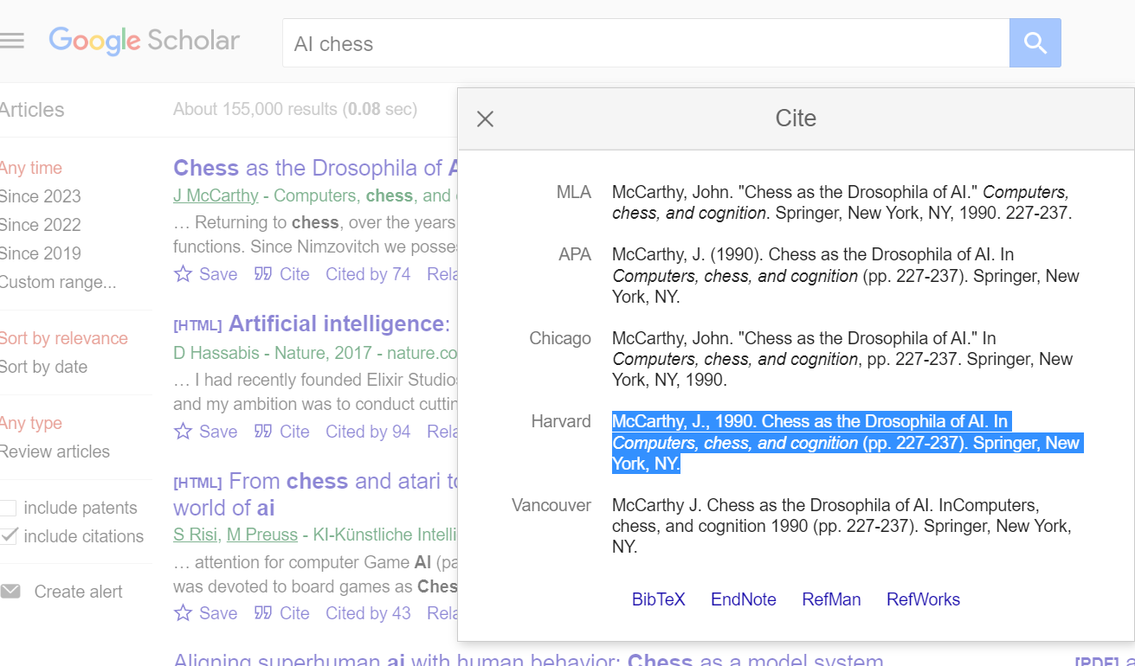

Www.scopus.com
https://www.webofscience.com/

